LAB Activity

**Task 1.** Install the simulator: **Cisco Packet Tracer** on your PC. The installer is in the flash drive which was given to you upon enrollment.

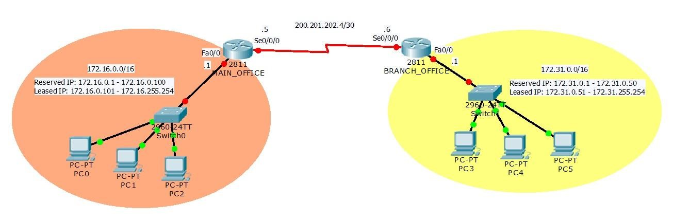

**Task 2.**

Run the

***DHCP Lab.pkt***

file

and

configure the two routers with the following settings:

MAIN_OFFICE Router

* hostname: **(your first name)_OFFICE**
* secure console, auxiliary and vty 0 4; password: **(your first name)** ; sessions must logout after **4 minutes** of inactivity
* secure privileged mode **without encryption**; password: **(your middle name)**
* **do not encrypt plain text passwords in the config**
* configure the interfaces' (fastEthernet 0/0 and Serial 0/0/0) IP addresses (follow the IP addresses on the diagram)
* configure DHCP and follow the reserved and leased IP range on the diagram. DHCP clients’ default gateway must be the router’s IP address. You can use any dhcp pool name you want. No need to set the lease time.
* configure the three PCs (PC0, PC1, PC2) to use DHCP in their IP Configuration settings.

BRANCH_OFFICE Router

* hostname: **(your surname)_DEPARTMENT**
* secure console, auxiliary and vty 0 4; password: **(your first name)** ; sessions must logout after **3 minutes** of inactivity
* secure privileged mode **without encryption**; password: **(your middle name)**
* **do not encrypt plain text passwords in the config**
* configure the interfaces' (fastEthernet 0/0 and Serial 0/0/0) IP addresses (follow the IP addresses on the diagram)
* configure DHCP and follow the reserved and leased IP range on the diagram. DHCP clients’ default gateway must be the router’s IP address. You can use any dhcp pool name you want.
* configure the three PCs (PC3, PC4, PC5) to use DHCP in their IP Configuration settings.

**Task 3.** Take a screen shot of the **show running-config** output of the two routers. Save the file as **main_srun** and **branch_srun**. This is to check if you have configured the required settings correctly.

**Task 4.** Take a screen shot of the **show ip interface brief** output of the two routers. Save the file as **main_siib** and **branch_siib**. Make sure all the interfaces are "Status UP, UP".

**Task 5.** Take a screen shot of the **show ip dhcp binding** output of the two routers. Save the file as **main_dhcp** and **branch_dhcp**. Make sure all the PCs received an IP address from their DHCP servers.